**Experiment 1.1**

**Student Name:   Gaurav Kumar                                UID: 22MCC20177**

**Branch:   CC-DevOps                                                        Section/Group: 1/B**

**Semester:   I                                                               Date of Performance: 18/10/2022**

**Subject Name:** **Linux Administration Lab Subject Code: 22CAP-648**

1. **Suppose recently your company switched their operating systems from Microsoft to Linux. Now you have all documents in MS word, what you will do to save all of that work in Linux operating system?**

An office suite is designed to make things easy. It is a bundle of software put together to facilitate the work of an organization. Open-source office suites like OpenOffice and Liber Office have evolved considerably in recent years, and smaller businesses can benefit by using these free software in place of Microsoft Office.

**We can use the following software in place of MS word :**

* Apache OpenOffice, which is a comprehensive suite for Windows, MacOS and Linux.
* Open Document Foundation’s Liber Office, which is a fork of OpenOffice for Windows, Mac OS and Linux.
* Neo Office, a Java based branch of OpenOffice for Mac OS.
* Calligra, which runs on Windows, Linux, free Berkeley Software Distribution (BSD) and Mac OS.

1. **Perform installation of Red hat Linux in dual boot. Explain the detailed steps along with screenshots.**

**Step 1:** Download the image file of Red hat RHEL version from the internet

**Step 2:** Make a bootable usb using the any software such as Rufus

**Step 3:** Plug in the usb boot the system using bootable usb

**Step 4:** You will seeing this type ofscreen select **Install Red Hat Enterprise Lnux**

and hit enter.

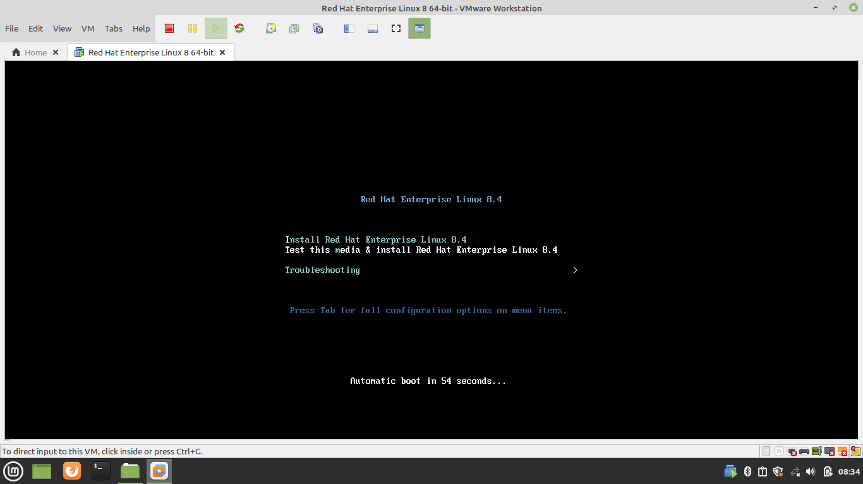

**Step 5: Welcome RHEL Virtual Machine**

After initiating the installation. You will be treated with a welcome screen on which you will see the option to select the language. Select your language and click Continue.

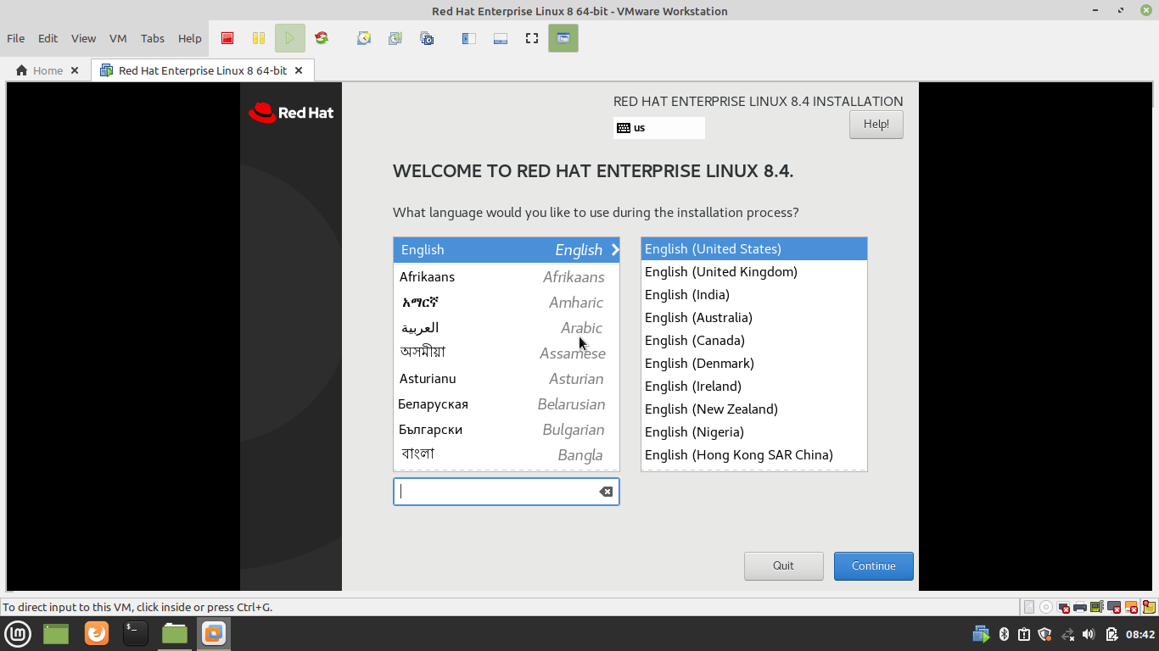

**Step 6: Configure the required installation settings**

Set the Keyboard, Language supports, Time and Date settings, Software package selections for installation, root password, Installation media, and disk partition information to proceed with the installation of RHEL.

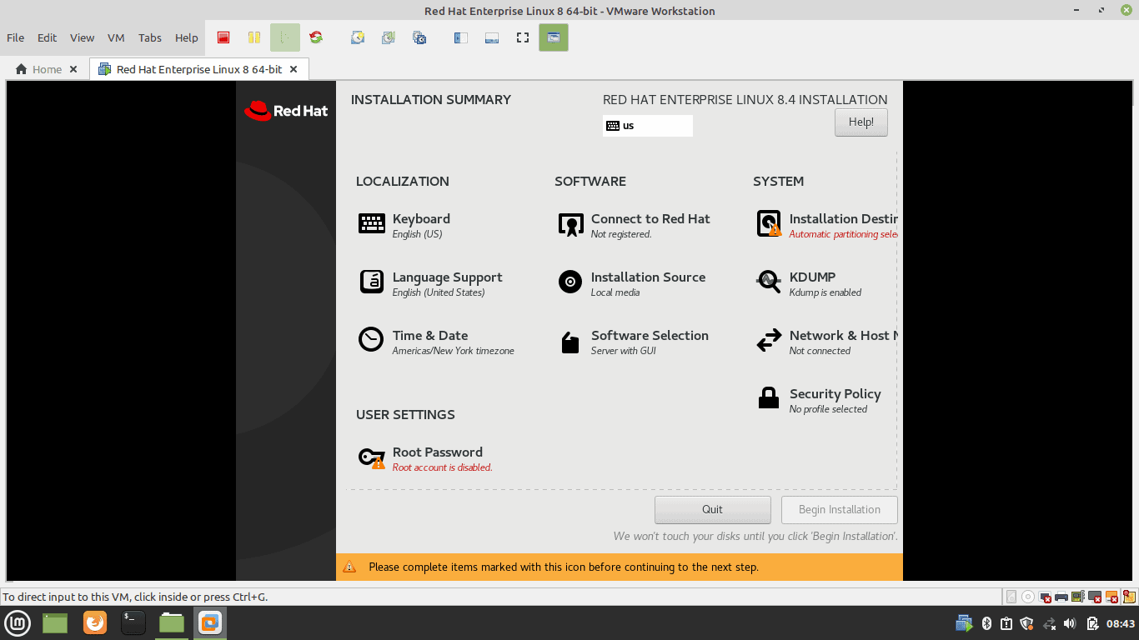

**Step 7:** **Partition the Disk**

Select the Disk to erase for auto partition. Or Select the Advance option to create the custom partition.

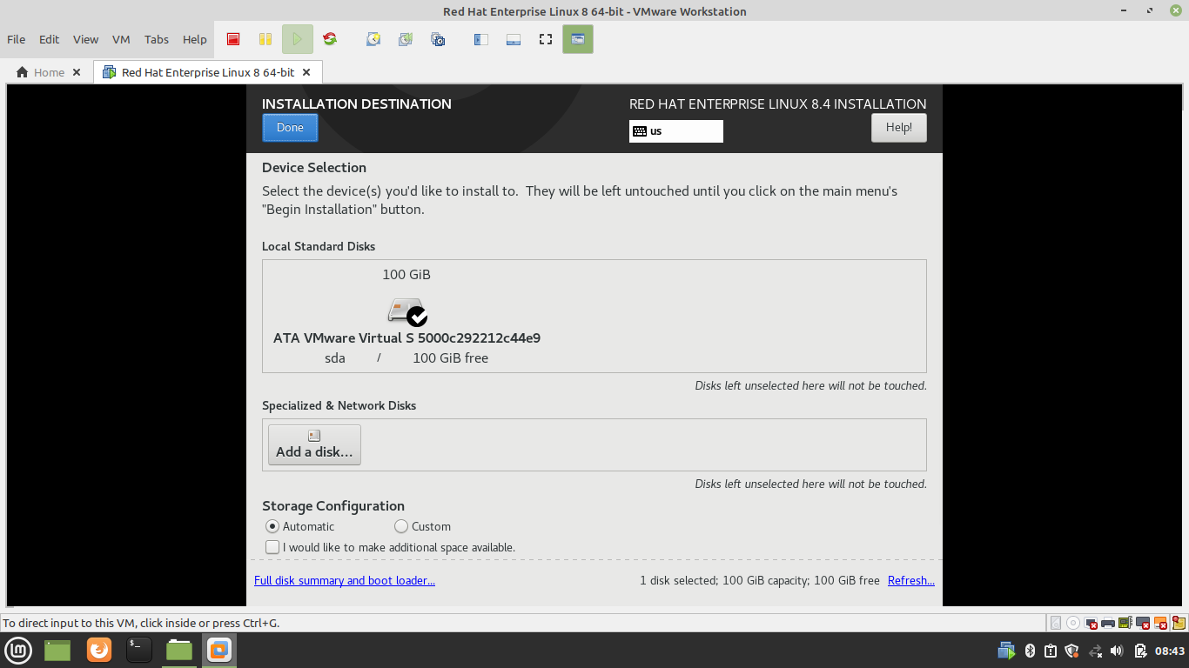

**Step 8: Set root account password**

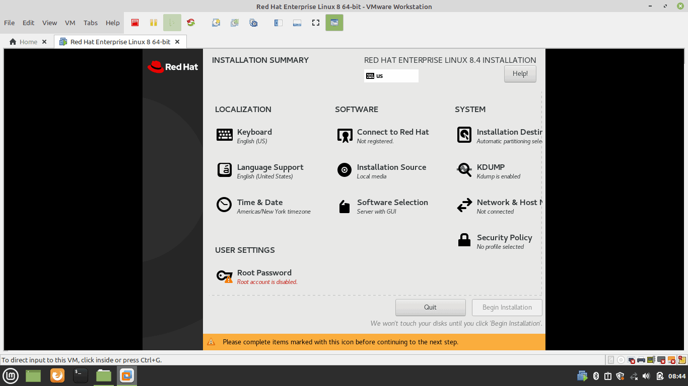

**Step 9: Begin Installation after setting up all the required settings**

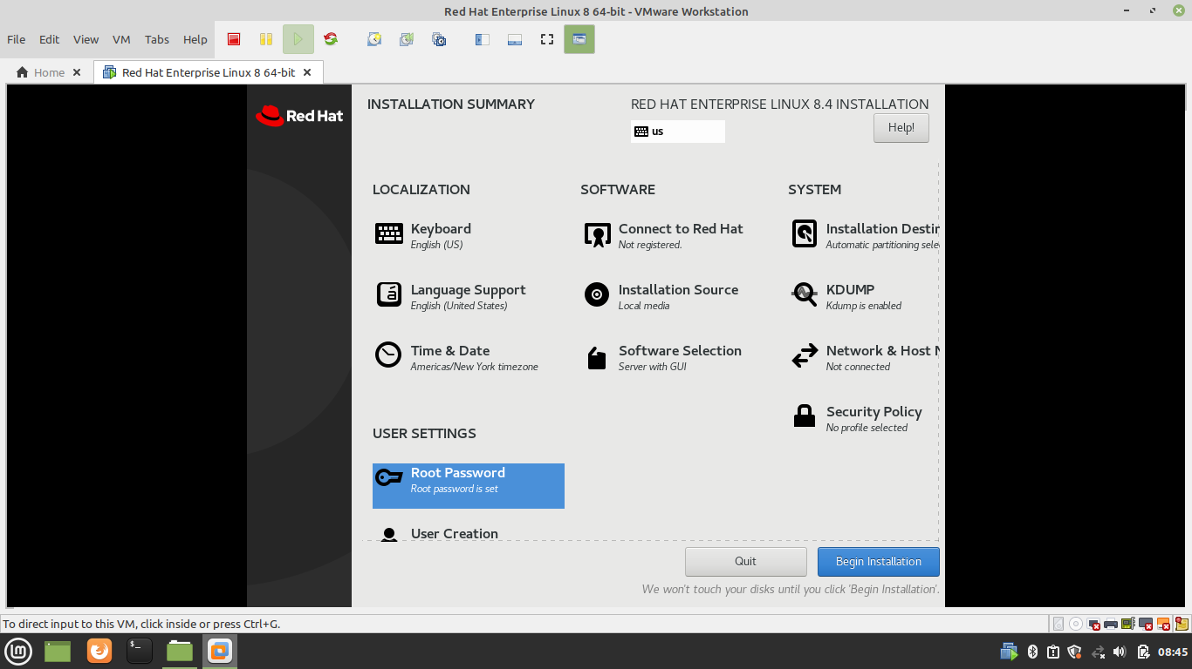

**Step 10:** **Installation of Red Hat OS is in Progress**

This process would take 15 to 60 minutes depends on your network bandwidth and package selection. Wait until it finishes.

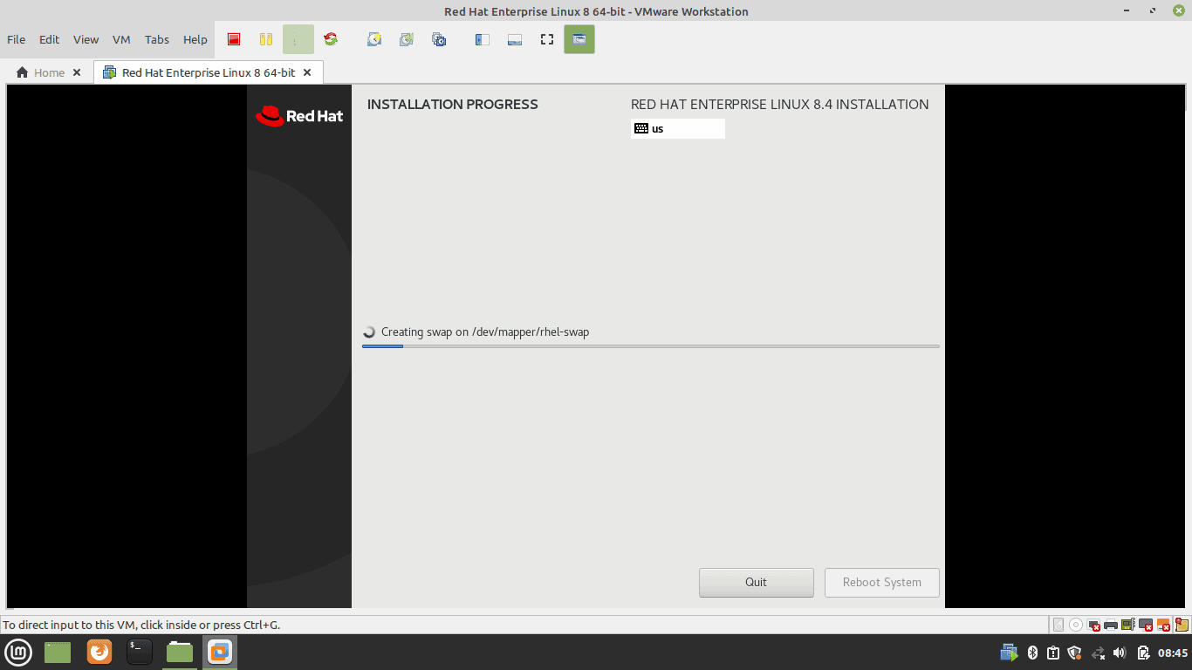

**Step 11:** **System Reboots**

Reboot the machine after installation.

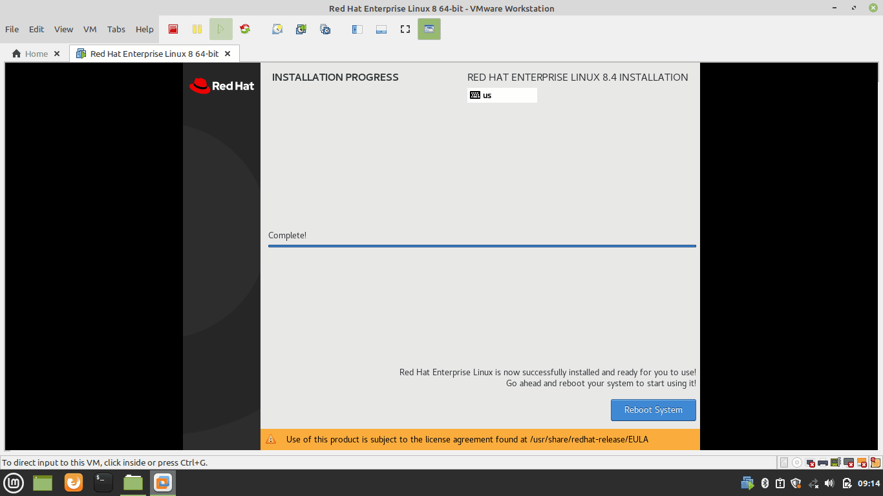

**Step 12: Select License Information upon reboot and accept the license**

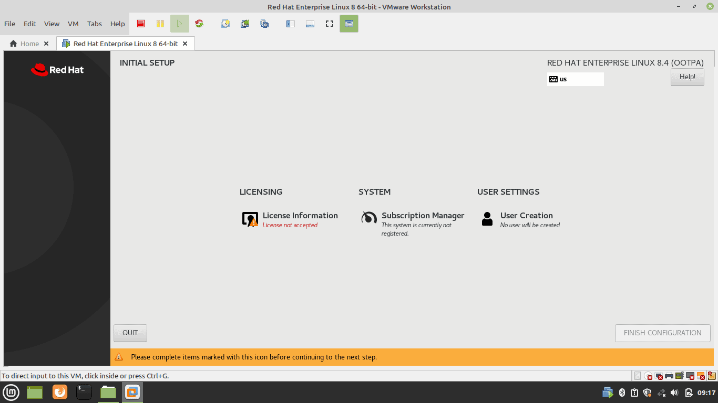

**Step 13: Tick – I Accept The License Agreement – Done**

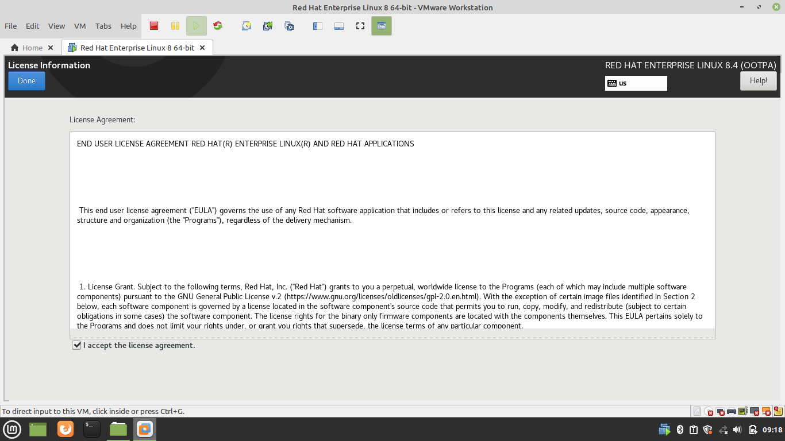

**Step 14:** **Create a user account**

Type Full Name, User Name (Tick Make This User Administrator & Require a Password to Use This Account), Password and Confirm Password – Done

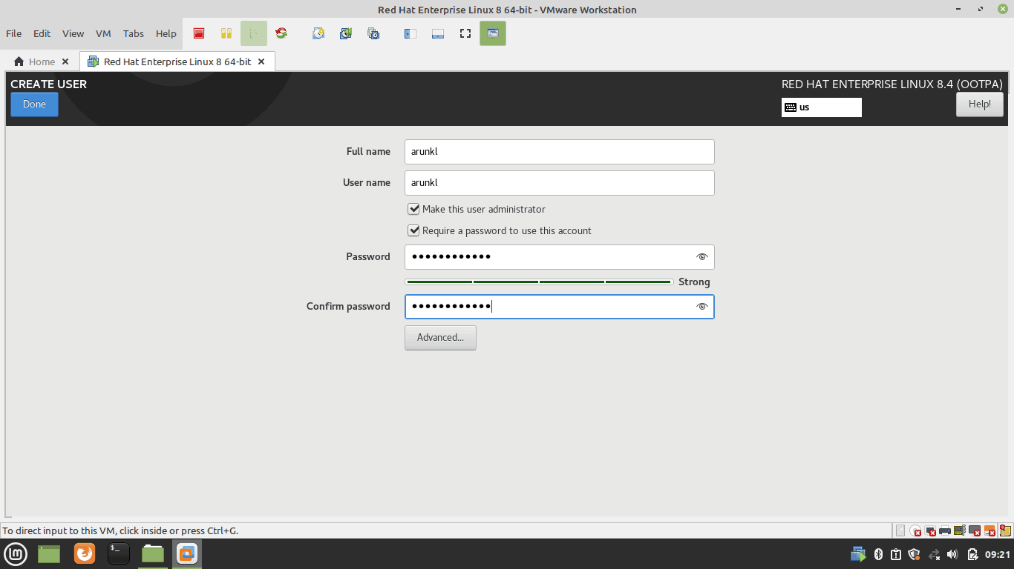

**Step 15:** **This will finish the configuration wizard**

Click Finish Configuration to continue.

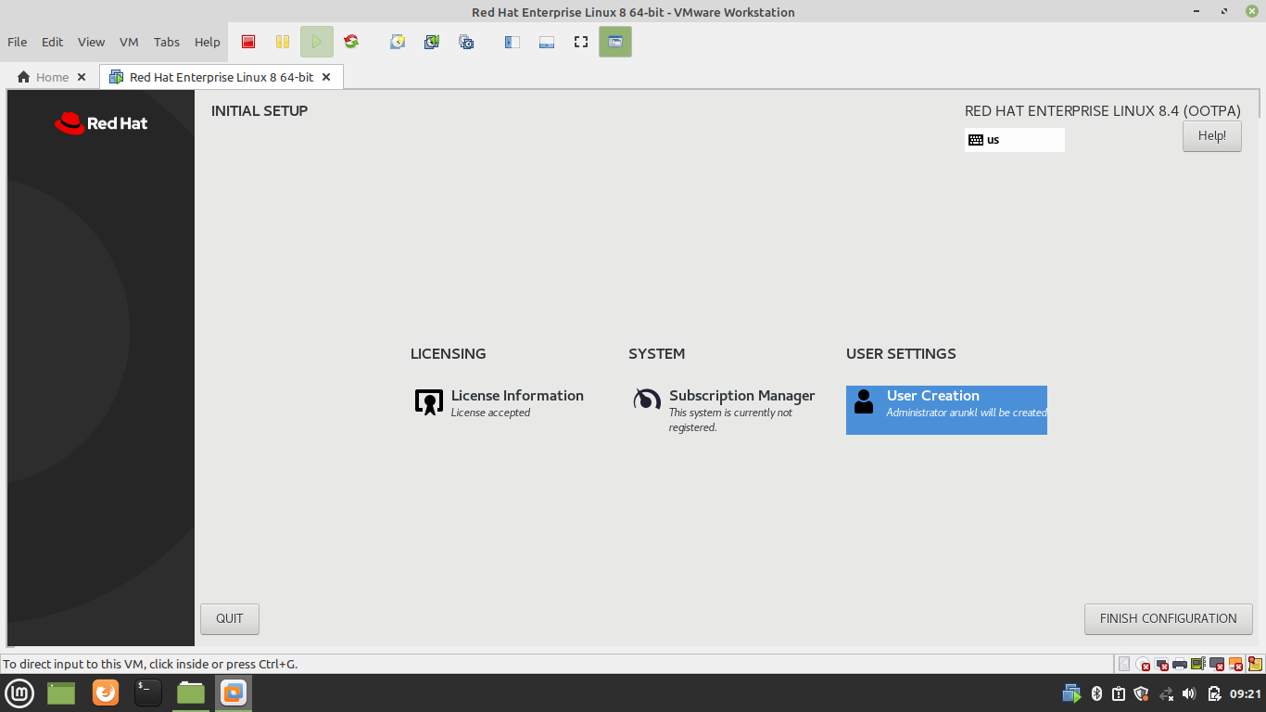

**Step 16:** **Sign In with user account**

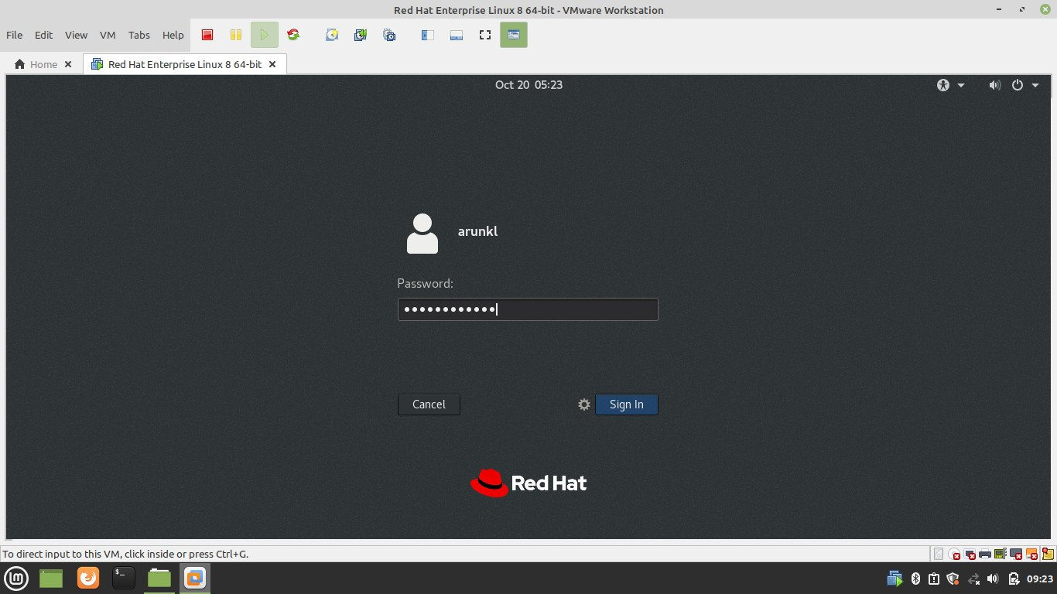

**Step 17:** **This completes the installation of RHEL on the VMWare Workstation**

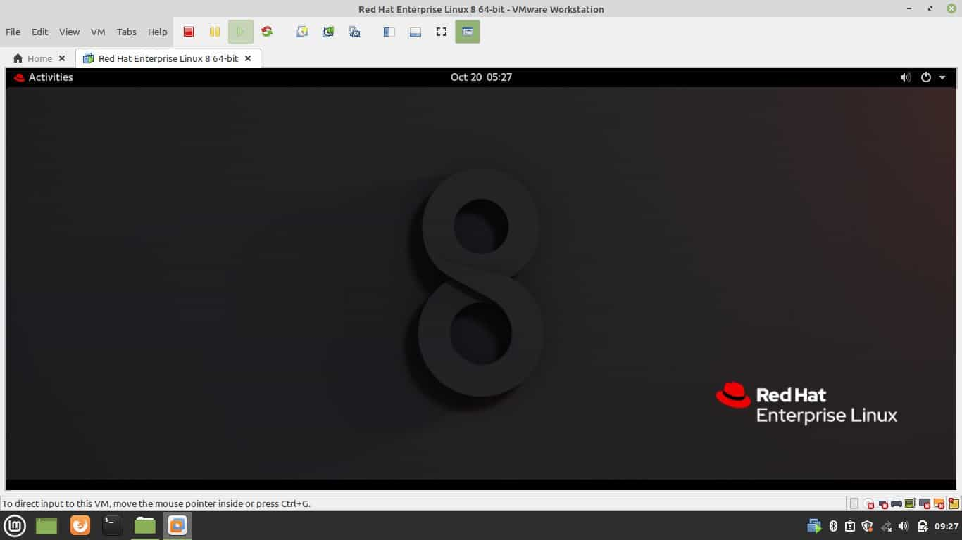

1. **Learning outcomes (What I have learnt):** 
   * 1. **About dual boot**
     2. **Installation of Linux**
     3. **Purpose of Linux**

**Evaluation Grid:**

|  |  |  |  |
| --- | --- | --- | --- |
| Sr. No. | Parameters | Marks Obtained | Maximum Marks |
| 1. | Demonstration and Performance  (Quiz) |  | 22 |
| 2. | Worksheet |  | 8 |